**CSE 6032 Computer Networks Prj2–Part2 Report18**

Student-Id and Name:1800003383-Pelin İNAN

1. **MyDNS Network and OS Settings**

Once you have implemented **Section B.6** run on MyDNS the “**ipconfig /all**” command and paste here after its screen shut containing OS and network settings (do not include Tunnel Adapter isatap section)**.**

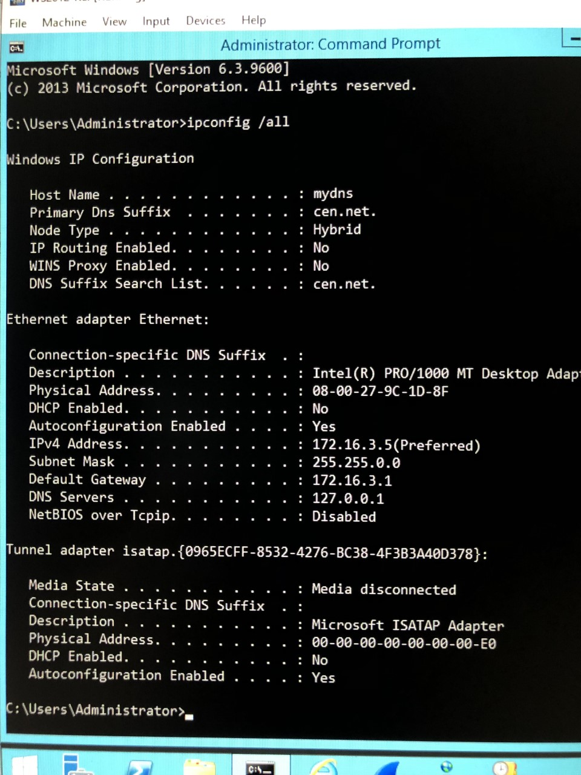

1. **Section C**
   1. Consider L2 frames you have captured in Section **C.2/ii**. Do the queries and replies pairs resolved the same FQDN? If the answer is YES explain briefly why? If NO write their difference.
   2. Consider L2 frames you have captured in Section **C.2/iv** to answer the questions here after.

|  |  |  |
| --- | --- | --- |
| **Question** | **Answer** | |
| Why did you capture frames over “Host-only Network” instead of the “Adapter for Loopback”? | localhost's ip address is 127.0.0.1. our computer is communicating with another computer. The computer creates a virtual card called loopback to provide access using the TCP/IP protocol. the entered data is directed to this address, that is, 127.0.0.1 represents our computer, so we caught the host only network. | |
| List the destination IP@ of query frames that are sent to root servers. | k.root-servers.net 193.0.14.129  e.root-servers.net 192.203.230.10  f.root-servers.net 192.55.5.241  j.root-serves.net 192.58.128.30 | |
| What is the destination **UDP port#** of the datagram embedded in a **L2 frame** carrying a **DNS** query? | 58866 | |
| Did you capture any ARP request /response frame? If so what is/are their purpose? | Yes I captured ARP. ARP generally used to find out MAC address. ARP is a link layer protocol. Pc is asking who has 172.16.3.5? And its understandable. |
| What is the **next-hop** of a **L2 frame** carrying a **DNS query?** |  |

* 1. Consider the screen shut in Section **C.4/ii** and try to explain how nslookup managed to resolve PQDN “mydns” and displayed correct FQDN and IP @ of the system?

if query is a PQDN nw. adapter “Connection-specific DNS suffix” is appended and we added the cen.net. (C.3/ii) additional Yes the correct FQDN and IP@ address of the system is displayed because the nslookup command uses dns. If we want to display the ip@ address correctly, we need to set up the ip on the dns server, and we did this on(C.3ii), so we got the right result.

1. **Section D.2**

Once you have implemented **Section D.2** paste here after the screen shut “d2.png” or “d2.jpg”.

